**TASK 2**

1. What are the steps involved in pre-processing a web request to process username header and profile loading of that that username before sending the request to the controller?

Use authentication filter.

* Each request is authenticated by authentication filter.
* It extracts header value and validate whether it is a valid request.
* In here I have used Header value as JWT Token .
* After get Header value(JWT token) can check username and other tags
* If the request is valid further process is done in use of controller, service and repository. Response is given with appropriate response codes.

1. What are the advantages of using these filters?

* Pre-Processing requests
* Can check Is correct user connect this API (Authentication users)
* CSRF Protection

1. Please design a sequence diagram and class diagram for this pre-processing filter

**Sequence Diagram**

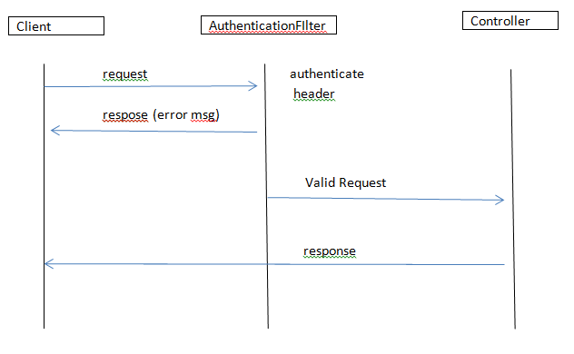

**Class Diagram**

